A DANGEROUS AMERICA: GLAAD’S ANNUAL ACCELERATING ACCEPTANCE STUDY REVEALS HIGH SUPPORT FOR EQUALITY AS LGBTQ AMERICANS FACE RISING RATES OF VIOLENCE AND HARMFUL LEGISLATION

June 1, 2023

Contact: [press@glaad.org](mailto:press@glaad.org?subject=PR%3A%20A%20DANGEROUS%20AMERICA%3A%20GLAAD%E2%80%99S%20ANNUAL%20ACCELERATING%20ACCEPTANCE%20STUDY%20REVEALS%20HIGH%20SUPPORT%20FOR%20EQUALITY%20AS%20LGBTQ%20AMERICANS%20FACE%20RISING%20RATES%20OF%20VIOLENCE%20AND%20HARMFUL%20LEGISLATION)

**LESS THAN 30% OF NON-LGBTQ AMERICAN ADULTS PERSONALLY KNOW A TRANSGENDER PERSON, DEMONSTRATING AN URGENT NEED FOR EDUCATION AND REPRESENTATION**

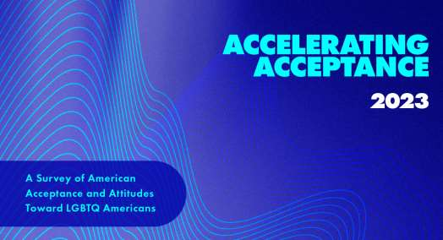

*Supermajority of non-LGBTQ Americans (84%) support equal rights for the LGBTQ community*

*Majority of non-LGBTQ Americans (70%) agree companies should publicly support the LGBTQ community through advertising, and sponsorships*

**Thursday, June 01, 2023**– GLAAD, the world’s largest lesbian, gay, bisexual, transgender and queer (LGBTQ) media advocacy organization, today announced the findings of its ninth annual *Accelerating Acceptance*study (hereinafter referred to as, The Study), which reveals that a record number of non-LGBTQ Americans support equal rights for the LGBTQ community. The Study also shows that an overwhelming majority of non-LGBTQ Americans now believe that LGBTQ people should have the freedom to live their life and not be discriminated against, and that schools should be a safe and accepting place for *all*youth.

With the release of this data, GLAAD finds that support for LGBTQ equal rights in America among non-LGBTQ people is now at an all-time high. Any narrative claiming otherwise, goes against a statistical supermajority of consensus, public opinion and American values. The Study also directly correlates how the epidemic of anti-LGBTQ legislation and online hate leads to higher levels of real-world harm for LGBTQ people, including but not limited to discrimination and violence.

Moreover, GLAAD’s *Accelerating Acceptance*study finds that while acceptance for LGBTQ people and youth have reached record highs, the research also reveals a significant lack of understanding and familiarity for nonbinary and transgender people. The Study directly correlates insufficient visibility and representation in media and advertising for these communities of people to a lack of familiarity as individuals who comprise the LGBTQ community at large. This signals a heightened need to represent intersectional touchpoints of nonbinary and transgender experiences across all media, from TV, film, publishing, journalism, gaming, advertising and more.

Across corporate responsibility and representation, the Study also finds that a significant number non-LGBTQ Americans agree that companies *should*publicly support and include the LGBTQ community through hiring practices as well as advertising and sponsorships.

***Read the full report now at:***[***GLAAD.org/Acceptance***](https://www.glaad.org/Acceptance)

**Major Findings:**  
Universally, non-LGBTQ Americans overwhelmingly agree that LGBTQ people should be free to live their lives and not be discriminated against. Yet, GLAAD knows that a majority of LGBTQ people are experiencing discrimination. There is also universal agreement that schools should be safe and accepting places for all youth, and children should be taught to appreciate and accept people as they are:

* *A 96% supermajority of non-LGBTQ Americans agree that schools should be a safe and accepting place for all youth.*
* *A 91% supermajority of non-LGBTQ Americans agree that LGBTQ people should have the freedom to live their life and not be discriminated against*
* *An 84% supermajority of non-LGBTQ Americans support equal rights for the LGBTQ community*

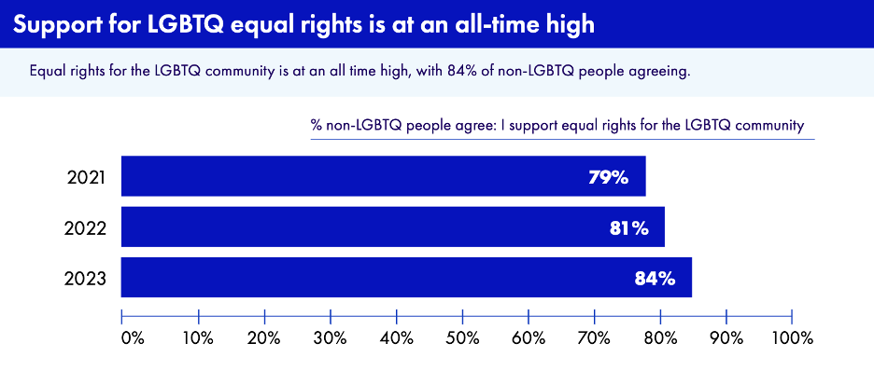

**On the Familiarity of LGBTQ People in America:**  
GLAAD’s Study found that there are feelings of unfamiliarity and misunderstanding of the specific dimensions that compose the LGBTQ community. This unequivocally points to the need for increased exposure and visibility, alongside fair and accurate representation of specifically nonbinary and transgender experiences in media:

* *55% of non-LGBTQ Americans do not understand the dimensions of the LGBTQ community or how to describe individuals that make up the LGBTQ community.*
* *Less than 30% (28%) of non-LGBTQ Americans say they personally know a transgender person.*
* *50% of non-LGBTQ Americans agree that nonbinary and transgender people are new and/or unfamiliar to them.*

**On the Comfortability of LGBTQ Representation in Media:**  
When people are exposed to LGBTQ people and experiences in media, it changes hearts and minds and shifts culture and sentiment. Measuring comfortability in media is a pathway to 100% acceptance for LGBTQ people:

* *75% of non-LGBTQ adults feel comfortable seeing LGBTQ people in advertisements.*
* *73% of non-LGBTQ adults report feeling comfortable seeing LGBTQ characters included in TV shows or movies.*
* *68% of non-LGBTQ adults feel comfortable seeing an LGBTQ family with children included in an advertisement.*
* *60% of non-LGBTQ adults agree that seeing LGBTQ in ads make them more comfortable with people who are different than themselves.*
* *Non-LGBTQ adults who are exposed to the LGBTQ community in media are 30% more likely to feel famliar with LGBTQ people overall, compared to people who haven’t been exposed to LGBTQ people in content or media.*

**On Visibility Across Corporate Responsibility*:**  
GLAAD’s research concludes that non-LGBTQ people believe companies *should*publicly support our community through hiring practices and advertising.

* *70% of non-LGBTQ adults agree companies should publicly support the LGBTQ community through hiring practices, advertising, and/or sponsorships.*

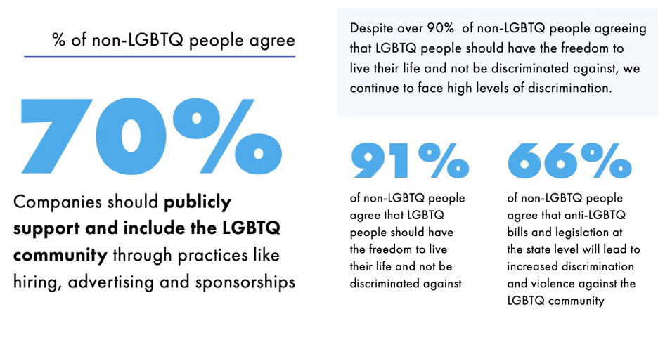

*GLAAD’s industry-first *Ad Index report*, focused on elevating LGBTQ representation across advertising, which includes both reality checks and playbooks for visible corporate responsibility breaks later this summer.

**On the Comfortability of Interacting with LGBTQ People, Family Members and Medical Providers:**  
From including LGBTQ people in places of worship, to learning that a family member is LGBTQ, to knowing your doctor is LGBTQ, a majority of non-LGBTQ adults are comfortable interacting with LGBTQ people. However, comfortability wanes for nonbinary and transgender people:

*Shared Place of Worship Comfortability*

* *80% of non-LGBTQ adults are comfortable having a gay, lesbian or bisexual person at their place of worship.*
  + *76% of non-LGBTQ adults are comfortable having a nonbinary person at their place of worship*
  + *76% of non-LGBTQ adults are comfortable having a transgender person at their place of worship.*

*Family Member Comfortability*

* *75% of non-LGBTQ adults are comfortable learning a family member is gay, lesbian or bisexual*
  + *68% of non-LGBTQ adults are comfortable learning a family member is nonbinary.*
  + *66% of non-LGBTQ adults are comfortable learning a family member is transgender.*

*Public Display of Affection Comfortability*

* *74% of non-LGBTQ adults are comfortable seeing a same-sex couple holding hands*

*Medical Provider Comfortability*

* *72% of non-LGBTQ adults are comfortable learning their doctor is gay, lesbian or bisexual*
  + *64% of non-LGBTQ adults are comfortable learning their doctor is nonbinary.*
  + *63% of non-LGBTQ adults are comfortable learning their doctor is transgender.*

**On False Claims About LGBTQ People and the Impact of Online Hate:**  
Data from [Equality Federation](https://www.equalityfederation.org/post/lgbtq-communities-fight-back-against-coordinated-nationwide-assault) show over 500 anti-LGBTQ bills this year. Each of the previous two years – 2022 and 2021 – were record-setting years for anti-LGBTQ legislation. Misinformation and the spread of false narratives about the LGBTQ community remain at an all-time high, despite record acceptance figures:

* *66% of non-LGBTQ Americans believe the false claim that the LGBTQ community is one group who all share similar needs and issues.*
* *54% of non-LGBTQ people believe the false claim that people who use they/them pronouns are, “in the process of figuring out who they are.”*
  + *This claim is false because pronouns are used to refer to individuals as who they are in their fullness. Getting pronouns right is also not exclusively a transgender issue.*
* *86% of non-LGBTQ Americans agree that exposure to online hate content leads to real-world violence,*

**From GLAAD President & CEO, Sarah Kate Ellis:**  
*“While these results are a clear demonstration that fair and accurate representation in media and journalism have a powerful and measurable effect on the lives of LGBTQ people, America is at a critical juncture when it comes to LGBTQ acceptance and safety. Support for LGBTQ equality has reached an all-time high, but allyship must turn into action. Media, content creators, and corporate leaders need to lead and respond to hate with undeterred support for the LGBTQ community, including LGBTQ employees, shareholders and consumers. Allyship is not easy, but when values of diversity, equity and inclusion are tested, we must defend them unequivocally."*

***Read the full report now at:***[***GLAAD.org/Acceptance***](https://www.glaad.org/Acceptance)

**Additional Data on LGBTQ Representation in the U.S.:**  
[Gallup](https://news.gallup.com/poll/470708/lgbt-identification-steady.aspx) polling released in February of this year showed that the percentage of U.S. adults’ identification as lesbian, gay, bisexual, transgender or something other than heterosexual held steady in 2022, at 7.2%. That figure is double what it was when Gallup first measured LGBT identification a decade ago. Also according to Gallup, adult members of Generation Z, those born between 1997 and 2004 who were aged 18 to 25 in 2022, are the most likely subgroup to identify as LGBT, with 19.7% doing so. The rate is 11.2% among millennials and 3.3% or less among older generations. In Generation Z, 13.1% say they are bisexual, 3.4% are gay, 2.2% are lesbian, and 1.9% are transgender. Each of those percentages is higher than it is for all other generations.

**Additional GLAAD Reporting and Research:**  
GLAAD is a leader across media industries using data-backed initiatives alongside proprietary research and reports to empower and equip everyone to be effective stewards of LGBTQ representation and visibility to reflect the world we live and do business in. Learn how to take action for our community at [glaad.org/ActNow](https://www.glaad.org/actnow) and see our research, including previous annual editions of GLAAD’s *Accelerating Acceptance*study at [glaad.org/publications](https://www.glaad.org/publications).

**Methodology:**  
GLAAD’s *Accelerating Acceptance Study*was conducted online in February 2023, among a national sample of 2,533 U.S. adults, age 18 or over, using sample sourced by Cint (who has the world’s largest consumer network for digital survey-based research). Data were weighted to ensure results represent the adult 18+ U.S. population.